ADIDAS PREDATOR GOALKEEPER GLOVES
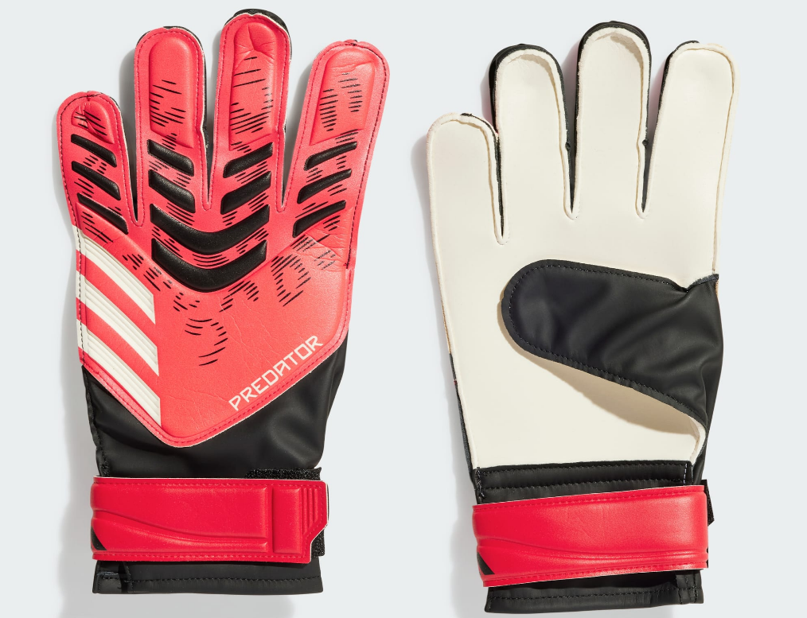
PRICE: Approximately Rs. 6,499

_{Introduction:}
The Adidas Predator Goalkeeper Gloves are engineered for goalkeepers who demand maximum control, grip, and confidence in every save. Designed to perform under pressure, these gloves combine advanced grip technology with a secure, comfortable fit. Whether facing powerful shots or making quick reflex saves, the Predator gloves support goalkeepers at every level. Built with Adidas’ football expertise, they offer reliability, precision, and professional-grade performance.
Product Overview:
The Adidas Predator Goalkeeper Gloves are designed to enhance ball control and hand stability during matches. Their high-grip palm and supportive construction help goalkeepers maintain control in both dry and slightly wet conditions.
About the Brand:

is a world-renowned sportswear brand known for innovation, quality, and timeless design. With a strong legacy in both sports and streetwear culture, Adidas continues to create footwear that blends performance, style, and durability for global audiences.

Key Features:
- FIFA-approved match gloves design
- High-grip palm for improved ball control
- Secure wrist closure for a stable fit
- Flexible design for natural hand movement
- Durable construction for regular use
- Suitable for training and match play

Design & Build Quality:
The Adidas Predator Goalkeeper Gloves feature a modern, ergonomic design that supports natural hand positioning. The reinforced backhand adds structure and protection, while the snug fit ensures confidence during fast-paced play. Its seamless construction reduces water absorption and ensures consistent performance, even during high-speed play.
Storage & Capacity:
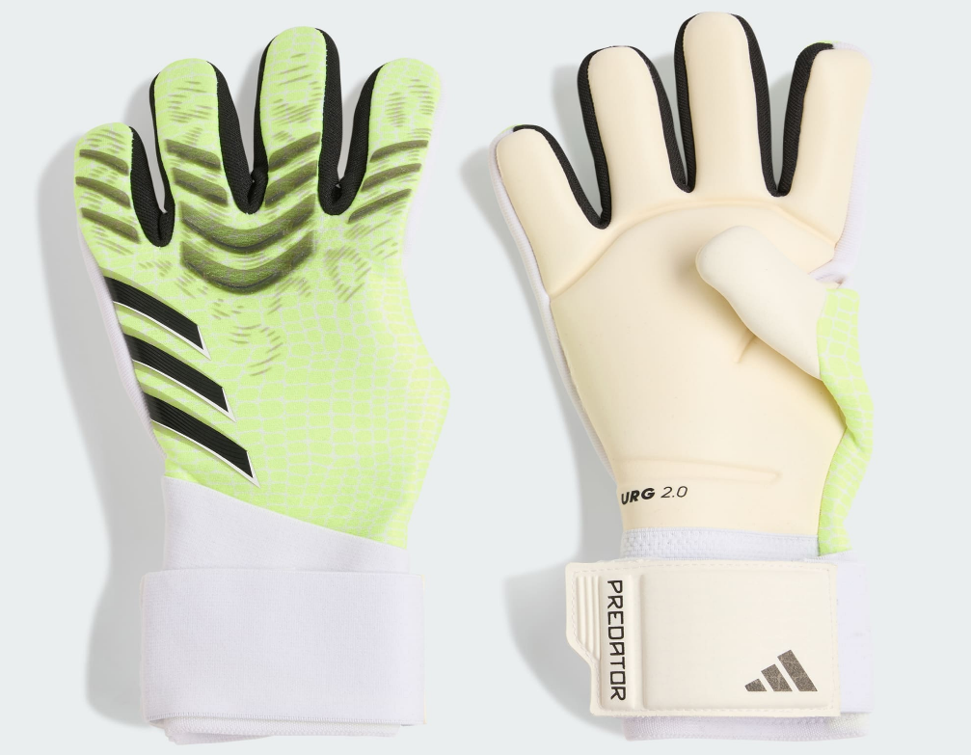
The ball maintains its shape when properly inflated and stored. It can be easily carried in standard sports bags and stored without deformation when kept in a dry environment.

Material & Durability:
Made from premium synthetic materials, the Adidas FIFA World Cup Ball is built to withstand intense match use. The outer surface resists wear and tear, ensuring long-lasting performance across multiple games.
Ideal For:
- Professional football matches
- Competitive tournaments
- Advanced training sessions
- Players seeking elite-level performance
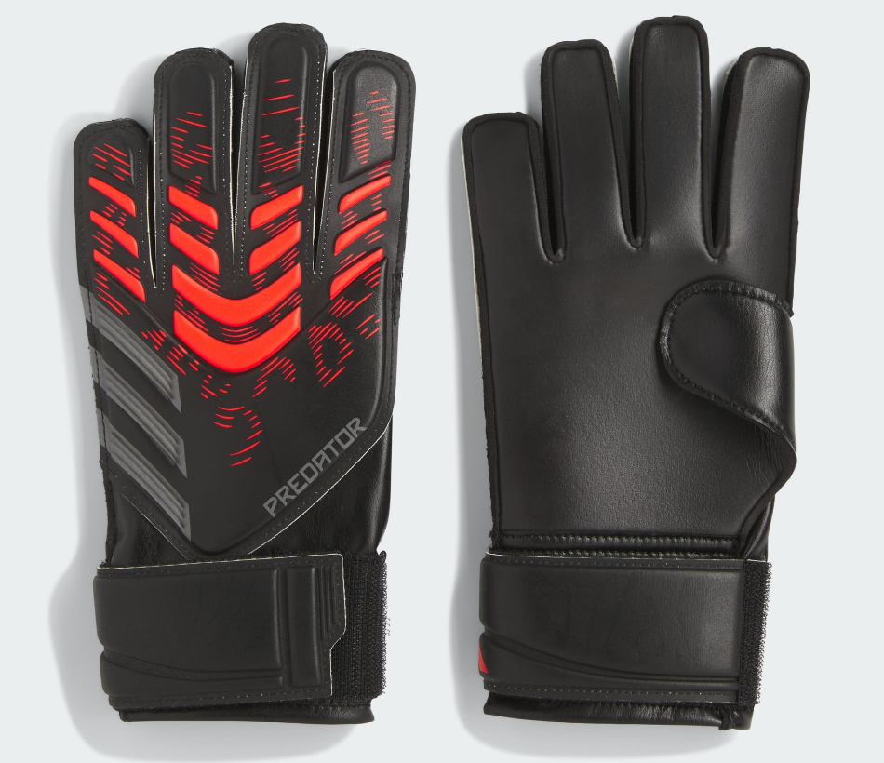

Care Instructions:
- Clean with a damp cloth after use
- Do not machine wash
- Store in a cool, dry place
- Avoid over inflation
Product Specifications:
- Brand: Adidas
- Product Type: Goalkeeper Gloves
- Model: Predator
- Palm Material: High-grip latex
- Fit Type: Regular / Secure fit
- Closure: Adjustable wrist strap
- Usage: Training & Match Play

Product Summary:
The Adidas Predator Goalkeeper Gloves offer excellent grip, comfort, and durability for dependable goalkeeping performance. Designed for control and confidence, they are a reliable choice for goalkeepers looking to elevate their game.

